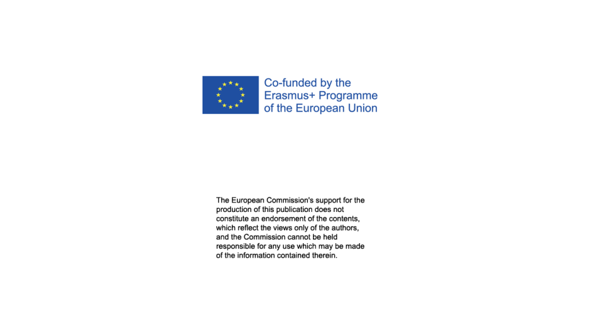
Education for sustainability and resilience
2022. Highlights from practise based teaching and learning. Volume 2. Number (1).

Title: Ådalen - the village of the future
Author: Krista Kaihovirta

INTRODUCTION
- What did you do and why, and how did you start your project?
- Insert an image if you have one.
I'm working as a primary school teacher in third-grade in Katarinaskolan in Raseborg. Raseborg is a municipality located in the Uusimaa region of southern Finland. The municipality is known for its historical sites, such as the Raseborg Castle ruins and the old ironworks Fiskars and Billnäs Villages. These are popular tourist attractions. Our school is located in the town of Karis and we have approximately 300 pupils in our school. In every grade we have between 2-4 classes (a-d).
PhD Ann-Catherine Henriksson contacted me and asked if I was interested in joining the Erasmus+ -project about sustainability and resilience. At once I became interested and after a while we were planning a storyline together with my colleague Marika Laaksonen. Together with Marika we brainstormed different options for how to build up the story in my class and we got crucial input from Ann-Catherine and we had very interesting discussions. Ann-Catherines task was to study whether the storyline approach could positively influence pupils' attitudes and environmental awareness. We conducted the same questionnaire both at the beginning and at the end of the storyline. In addition to that, the pupils were also interviewed by Ann-Catherin. We got the opportunity to visit Backatorpsskolan in Gothenburg and that visit also gave us more inspiration for the storyline. Through the visit we saw in practice what a versatile and inclusive method storyline really is. We familiarise ourselves with the finished storyline plans that we found on the storyline.se pages and were especially inspired by the storyline FramtidensBoende - a storyline about energy and living in the future.
One of the central themes of the project was to engage the pupils to learn about a sustainable lifestyle and see their own life and the society around them in a larger context. It can be said that much of the project revolved around the following quote taken from the Fundamentals of the Finnish Basic Education Curriculum 2014:
"Sustainable development and lifestyle can be seen from an ecological, economic, social and cultural perspective. The leading idea in eco-social education is to create a lifestyle and culture that protects the inviolable value of humans and the diversity and ability of ecosystems to renew themselves, as well as to simultaneously build a knowledge base for a circular economy based on the sustainable use of natural resources."

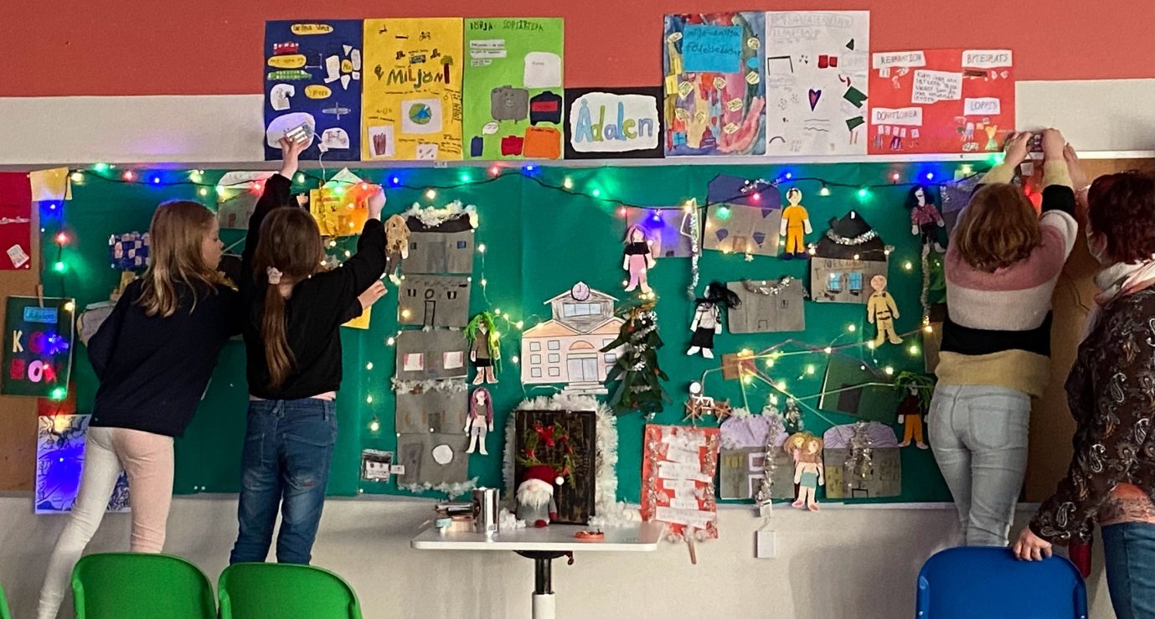
PLANNING
Because this was the first time we were planning a storyline, we considered first basing the storyline fully on an already existing storyline about energy and living in the future. But in the end we transformed it to fit our thoughts, the curriculum and our classes. The planning matrix became ​​the basis of the storyline. It included the key questions, activities during each week, working groups, materials that are used and the products of the week. The instructions were written to open up the workflow and are read together with a matrix. The same headings are found in the matrix that follows the instructions.

Time frames and home groups
Throughout the storyline, the pupils work in groups that then form neighbourhoods in Ådalen, the village that is built up step by step. In our classes, the pupils are divided into four colour groups which also formed the groups in the storyline work. Every pupil has its own caracter to react through. Each week begins with a letter from a fictional character who has something to do with Ådalen. These characters are played by teachers and with their help the story is driven forward. Each letter contains missions that make up that week's storyline work. The assignments require approximately 3 lessons a week over a six week period. Some assignments could be developed further and you are guaranteed to have several lessons to attend if you so wish.

The structure of the storyline was this:

Week 1: Who lives in the neighbourhood?
Week 2: Where should we build Ådalen?
Week 3: How should we live as sustainably as possible?
Week 4: Ådalen's cookbook
Week 5: Ådalen's school, a place for everyone
Week 6: The Imagination Machine
Week 7: Conclusion and retrospect

During the story the inhabitants of Ådalen were supposed to solve the tasks together in their neighbourhoods. In the beginning they had to agree about the use of land. How to build and what housing form to choose? If they choose to build at the height, they have more space in their common yard. If the inhabitants chose to build owner-occupied houses, the yard became smaller but private.
The inhabitants had to solve the recycling and use of resources.
There were many points on which they had to take a stand and justify their opinions.

CONDUCTING
One Monday morning, the pupils find a letter and the character Anki Täckt in the classroom. Anki visits the class on a mission as the city architect for Ådalen, "river valley". Anki talks about her vision of the future village and that she is looking for volunteer residents who would build a village and start a sustainable life there. Anki presents the Ådalen project - the village of the future and hands out application forms.
After this the pupils looked forward to what the letter contained every Monday and who would show up. Often, it was a new character who introduced themselves to the group and gave them the task of the week.
Some of the key questions were: Where on the map are we building? What is important to be able to reach agreement with others? What kind of food can we produce ourselves? How can we live as sustainably and enjoyablely as possible? What kind of inventions are needed in the future?
During the following six weeks we builded up Ådalen and worked with the key questions.
The pupils were brainstorming and discussing the types of people who live in a society. A list was made of the professions needed for a society to function. A map was studied together and elevations and waterways were being observed. Potential locations for wind and water power were being considered. Together with the whole group, possible housing options were being discussed. The advantages and disadvantages of different forms of housing were being considered. The residents of the small town of Ådalen had started thinking about how to organise their lives in the most sustainable way possible. At the request of the chef Gunnar Gaffel, the residents were gathering recipes for dishes that could be prepared using local ingredients. Principal Regina Sträng from the school of Ådalen wished for the residents to provide examples of how to solve conflicts. She wanted the conflict situations and their solutions to be presented as movies, in which the residents themselves would become actors. The result was beautiful iMovie films.
These activities were all something that engaged the pupils in a great way. When they acted in the role of a character, they had more room to react and try out different opinions. That's the strength of a storyline. The frameworks for the storyline were carefully planned but also allowed for spontaneous elements to be included during the course of the story. For example, a debate about where to build Ådalen was an unplanned element and turned out to be very successful and unexpected pupils stepped forward and took stand in the debate.

EXPERIENCES
For being the first storyline we did with our groups, we were satisfied with the result and felt that the whole project was successful. We had a positive feeling afterwards, and it was difficult to take down the frieze from the classroom wall. The pupils were engaged throughout the project and had the opportunity to work in many different ways and in several different groupings. What we as teachers had confirmed was that careful planning proved to be very valuable. In fact, the planning allowed for more room for short, improvised elements and provided a sense of security for us as teachers to also take on the roles of our own characters that emerged during the story.
The pupils were waiting for Monday's new challenge. After a while, we often discussed how the residents of Ådalen would solve various problems and difficulties that we ourselves encountered in our everyday lives. Some of the pupils were upset that the town was going to be taken down from the wall, which delayed the project a bit. When we had decided how to end the story, it turned out really successful. What we as teachers learned was how important the ending was. The whole story would have suffered if we had just continued with it for too long. Many happy memories remained.
CONCLUDING THOUGHTS
A good storyline should be meaningful and relevant to the pupils. It must be engaging and interesting. A well-crafted storyline can use its narrative arc and characters to explore important topics and ideas, such as different feelings, environmental or social issues. The important thing is to document the entire project when creating a storyline. It can be reused and adapted by another teacher to make it their own. When a teacher familiarises themselves with storyline as a method, it is important that they themselves experience sequences of a storyline in order to understand what a great method it is for emotionally engaging the participants. It's quite demanding to just read up on the method. In our school, we tried to spread the method to our colleagues, but it was difficult to achieve a broader reception through instructions alone. In the future, we will hopefully be able to participate in proper training on storyline as a teaching method. As a big advantage, we have now created important contacts with Backatorp School in Gothenburg during this project. They work very professionally with the method and are happy to share their expertise, which I am very grateful for.
References

Häggström, Margaretha (ed.): Att undervisa i hållbar utveckling : relationellt perspektiv. Lund: Studentlitteratur 2022.
Lundin, Ylva: Framtidens boende. En storyline om energi. Konsument Göteborg 2005.
Kaihovirta, Krista & Laaksonen, Marika.Storyline projekt. Ådalen - framtidens by https://docs.google.com/document/d/15l7YadbCntST4M_pUrQl0jqx9rEimzsReYLlK0lQgVo/edit?usp=share_link (hämtad senast 5.5.2023)
Storyline Sverige: https://www.storyline.se/ (senast hämtad 5.5.2023)

