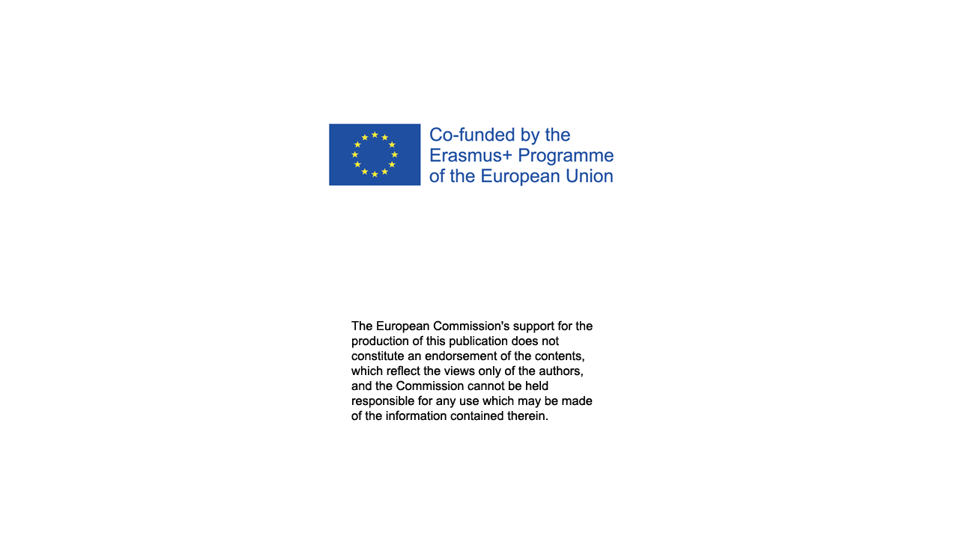

Understanding sustainability in teacher education;the Storyline Approach with Creative Covid-19 solutions
Norway’s Østfold University College (HiØ) teacher educators demonstratetheir resilience to the challenges of Covid-19 restrictions while using the Storyline Approach. Together, nine teacher educators, representing the department of teacher education and the National Center for English and Foreign Language (FSS),re-designedtheirannualStoryline project on sustainable development to a fully digital,covid-free, platform. Their creativity and collaboration demonstrated toseventy-onesecondyearlower secondary school student teachershow the Storyline approachcan be adapted for teaching and learning about the complex topic of sustainability.

Fotoko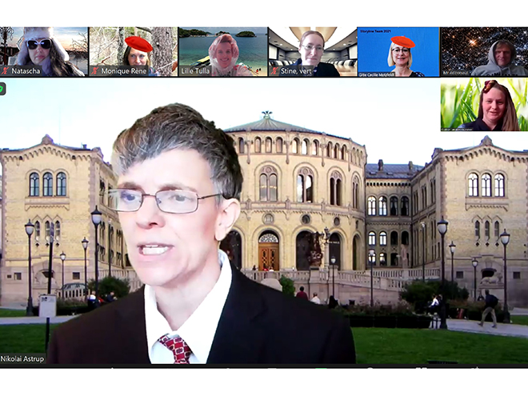.
Article by: Gini Lockhart-Pedersen, Fremmedspråkssenteret, Hanne Eik Pilskog at the section for science, Camilla Blikstad Halstvedt at the section for science, Gitte Cecilie Motzfeldt at the section for social sciences, Monica Nordbakke at the section for mathematics, Johan Bredberg at the section for mathematics, Gunhild Brænne Bjørnstad at the drama section, Jon Sverre Thorstensen section for music, Øystein Sverre Warem section for music and Kristine Høeg Karlsen, section for pedagogy.

Digital adaptions for the Storyline Approach

Since 2016, teaching and learning through the Storyline approach has been an integrated part of teacher education atHiØ. Over a two-week period, lower secondary school student teachersimmerse themselves in the interdisciplinary topic, sustainable development, using the Storyline approach as a frameworkto dive deeply intothe complex perspectives of the UN Sustainability Goal, . However, inJanuary 2021,restrictions for teaching on campus challenged the known framework of Storyline’s practical approach, causing the Storyline team at HiØ to re-think the frameworkand move the approach to a fully digital platform. The digital result proved to be a viableoption.

Meeting Spaces with Zoom and Microsoft Teams

From a combination of zoom rooms and Microsoft Team rooms, the all-digital "Storyline" wasimplemented, with each teacher attending from home and their own pc. Morning and afternoon administrativezoom meetings provided for the space needed to discuss the challenges of the day and plan for the following day. A common student zoom room, different from the administrative zoom room, brought together the 71 students forpresentations, events, and discussions that were common for everyone. Break-out rooms provided, the additional space needed for discussing key-questions and other Storyline group work. During the day, the student zoom room was open for participants and observers to enter and leave whenever, allowing outside observers and participants join the project at their convenience. During this digital Storyline, we had visitors from outside institutions, practicing teachers, and program leaders at HiØ.

Microsoft Teams was used as a platform for sharing files and messages both in the planning phase and during implementation. Microsoft Teams also provided for a private space for discussion during the day while the student zoom room was active, allowing for the teacher educators to collaborate throughout the day.

Digital Settings andCharacters
This digital storyline was about a Norwegian community established in a river delta. River deltas are an endangered habitat type found in several areas in Norway, and today, many delta communities experience conflicts between preserving and managing nature with its rich biodiversity and developing the community for its members and economic purposes. The digital storyline characters created in the Delta community were thefictional people who reflected and actedupon the unexpected events that occurredin the Delta community.Working on the digital platformcatered well to the creativity and esthetic experience of the student teachers. They created community members that included farmers, investors, domestic workers, fishermen, foreign workers, single mothers and young people. The students enhanced their characters by changing their zoom backgrounds, wearing different items of clothing, and using zoom filters on their voices and faces. In interviews taken after the experience, the students expressed how they found it easy to become another character when in the comfort of zoom rooms. This freedom for creating characters online was also visible through the college teachers, who quickly created charactersthat could pop in and out of the storyline in a planned manner or spontaneously.
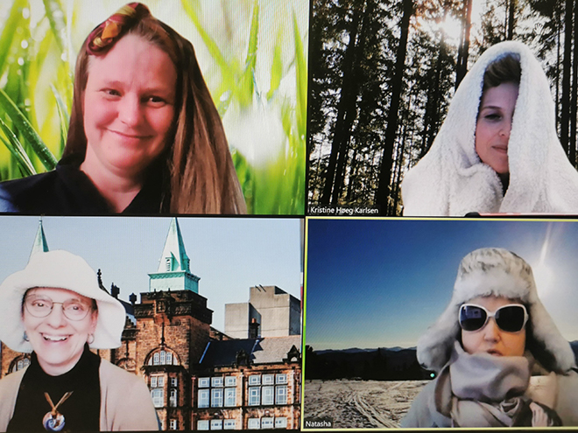Teachers-in-role. From left: Gunhild Brænne Bjørnstad, Kristine Høeg Karlsen, Gini Lockhart-Pedersen and Monica Nordbakke. Photo: Kristine Høeg Karlsen.

The Esthetic Experience
Providingan esthetic experience when making the setting for the Storylinedigitally presented a larger challenge. Using creative digital alternativesto the practical work with hands-on materials for a three-dimensional setting needed more digital knowledge than this Storyline Team had. However, student groups showed their creativity when producing the google sites used as a webpage for each Delta community.Further exploration of the digital possibilities for an esthetic experience while creating a setting is needed, which would add significantly to the Storyline approach if implemented online. In this Storyline, each Google site was then linked in a single Padlet where the students could easily access all the different Delta communities. Padlet also allowed for easy peer feedback for each Google Site.
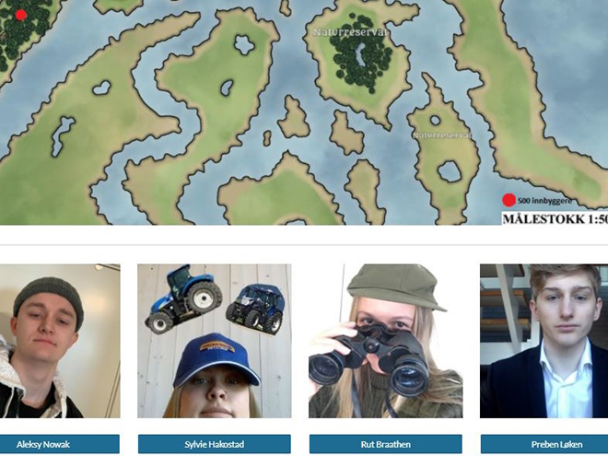
Student example of Google sites produced for their Delta Community.

In the end, the digital platforms created new opportunities to stimulate the student's creative skills in the development of the story, the exploration of the characters, and the topic of sustainability. The aesthetic subjects became important tools for establishing and maintaining the fiction that was created, which is the framework for the Storyline approach. The aesthetic subjects such as drama, art, and music, were linked to theoretical subjects through the digital possibilities to make visible the connection between all the subjects involved in this Storyline.
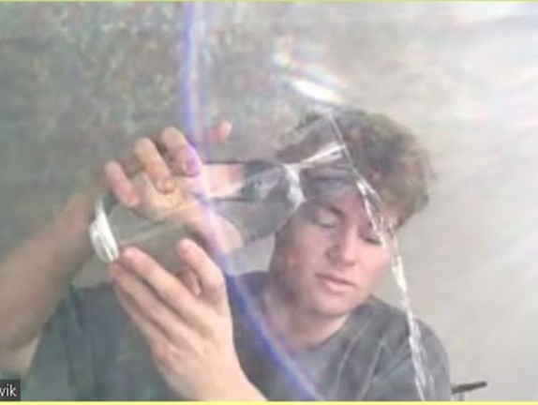
Sander Eldevik, MAGLU5-10 student. Experimenting with water for a sound orchestra. Photo: Camilla Blikstad Halstvedt.

Teaching and learning about sustainability
This storyline was developed with the aim of providing student teachers a student active and interdisciplinary approach tothe topic of sustainable development. In the digital version of this storyline, the opportunity toreflect from the perspectives of the student-created characters in the privacy of zoom rooms opened up for several in-depth discussions not always experienced in the previous physical storylines done in a classroom. Students demonstrated they could use their competence and personal opinions from their characters perspectives when engaging in their community discussions of future sustainable developments.
Research and the EU's Erasmus + program

Several student teachers have agreed to contribute to research, creating a data base that will be used in,«Education for resilience and sustainability», the EU's Erasmus + program. The other participating researchers from the University of Gothenburg and the Abo Academy in Finland will be part of examining Storyline as an interdisciplinary method for teaching and learning about sustainable development, along with how the digital implementation of the Storyline may create new opportunities for the approach in the future. In addition, this Storyline team collaborates with a research team at OsloMet.

Related links:
Film by Gini Lockhart-Pedersen made from the project (YouTube)
Webpage to FoUgruppen Creativity, art and innovation in education, practice and research

Relevant literature
Karlsen, K.H. & Virginia Lockhart-Pedersen. Story-based Cross-Curricular Teaching and Learning. A Systematic Mapping of the Research Literature on The Scottish Storyline Approach. In K.H. Karlsen & M. Häggström (Eds.) Teaching through Stories. Renewing the Scottish storyline Approach in Teacher and Higher Education. Germany: Waxmann publishing.
Karlsen, K.H., Motzfeldt, G.C., Pilskog, H.E., Halstvedt, C. B., Rasmussen, A.K. (2020). An exploration of the ‘mimetic’ aspects of Storyline used as a cross-curricular and creative approach to teaching and learning in Teacher Education. In K.H. Karlsen & M. Häggström (Eds.) Teaching through Stories. Renewing the Scottish storyline Approach in Teacher and Higher Education. Germany: Waxmann publishing
Toft, S. & Bjørnstad, G. B. (2020). Being in the moment – an investigation of the aesthetic learning process in a Storyline. In K.H. Karlsen & M. Häggström (Eds.) Teaching through Stories. Renewing the Scottish storyline Approach in Teacher and Higher Education. Germany: Waxmann publishing
Karlsen, K.H., Høeg, H.R., & Høeg, E. Cooperative learning: The power of Positive Interdependence in a cross-curricular Storyline on Sustainability. In K.H. Karlsen & M. Häggström (Eds.) Teaching through Stories. Renewing the Scottish storyline Approach in Teacher and Higher Education. Germany: Waxmann publishing.

